TANSTACK QUERY

- TanStack Query (formerly known as React Query), is a querying and state management library that simplifies the way we fecth, cache and synchronize data from a server. It not only simplifies the data fetching code but also handles complex requirements.
- 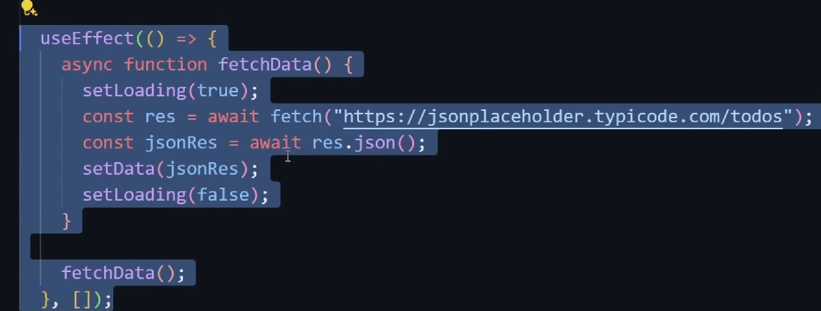
- Above, instead of using this logic, we can use tanstack query. It has hooks that have react state for data, loading, errors ..etc
- Npm I @tanstack/react-query, query client is the backbone of tanstack query, without it any tanstack methods we call, will have zero context on how to fetch and retrieve data.
- Query client should exist outside of a react component
- 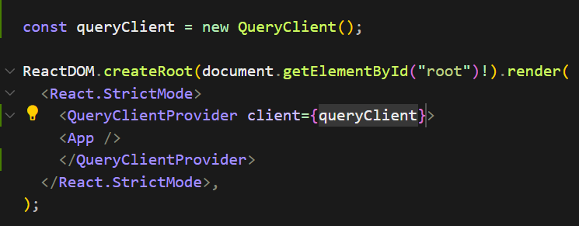
- Above, initializing queryclient
- Query key is used for refetch data and caching data. It should be unique. Coz if we give same for 2 dfrnt queries, then the queryClient can’t distinguish between two queries. queryFn is the function that will run, whenever we run the query with this key.
- Tanstack docs, data is the most important return from useQuery

- 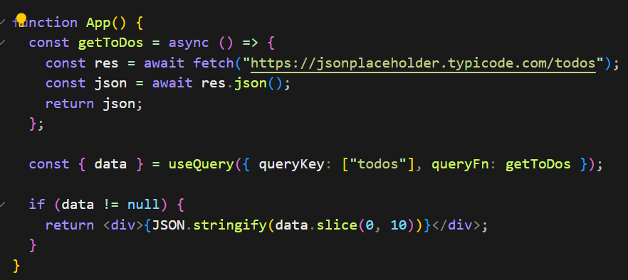

- Above, data is extracted and we wrote if condition and then returned JSON response. We gave the condition as data!= null, we can also remove this condition
- 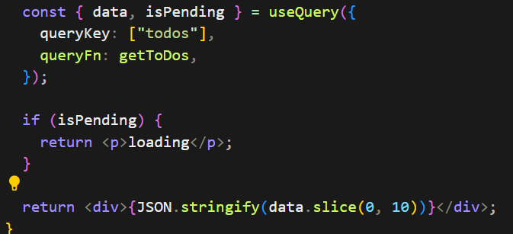
- Above, we destructured isPending also
- 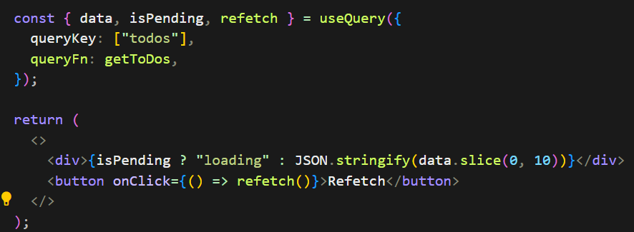
- Above, we destructured refetch. Now, the query will refetch when we click on Refetch button. When we click on refetch, it does not show loading. Coz here, this query is cached using the queryKey. It tells tanstack that we already queried this and it is already in the cache. When we click on Refetch button, it looks into cache and loads the data
- 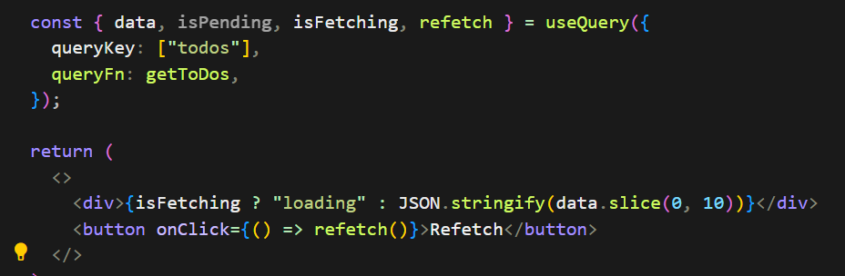
- Above, we destructured isFetching also. Now, it shows loading, both on first load and also whenever we click on Refetch button. isPending is mostly used.
- 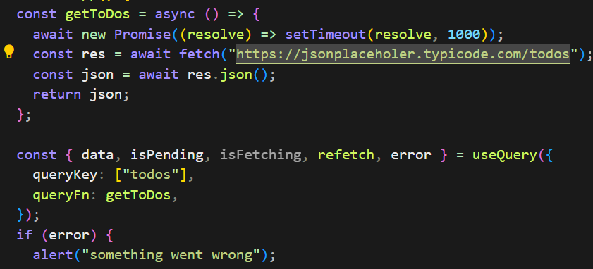
- Above, we destructured error also and we created an alert. We also mistyped the url. This is known as error catching and not caching.
- All these destructured props are part of useQuery hook. Instead of using useEffect and 4 or 5 hooks, we can go with useQuery
- Lets say there is an api endpoint with some id, we can pass this id to useQuery. Below pic,
- 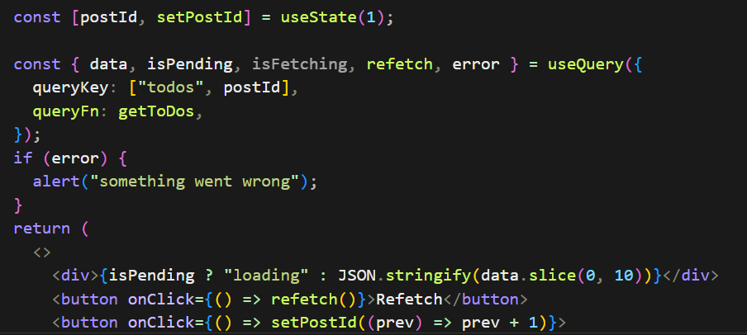
- Above, we created a hook with initial value 1, if we don’t pass this postID then usequery cant cache the query correctly. Lets say there are id 1 and 2 and if id is not part of useQuery, then the result of 2 queries will be similar and it results in problem.
- 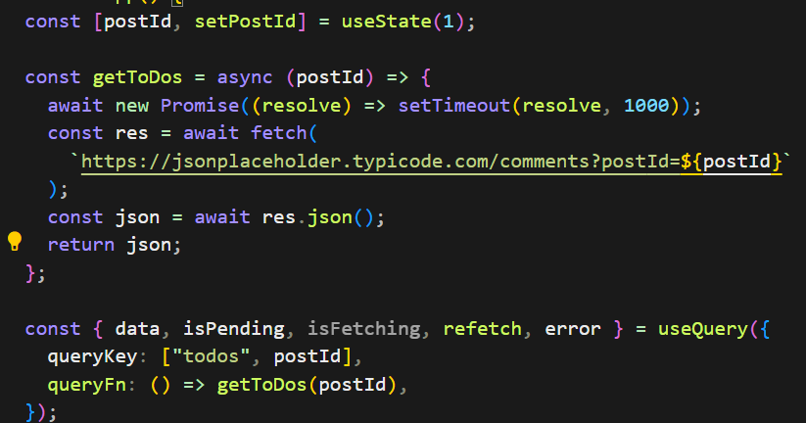
- Above, we used one hook and passed postID to endpoint and passed postid to querykey and queryFn (as a callback function, we should not give as getToDos(postId). If we don’t pass postID to queryKey, then clicking on Increment Id button to call the next endpoint wont work. Coz, useQuery does not know that it should make a new query with new postId. And if we don’t pass postId to queryFn, then it returns empty array.
- We cannot call hooks in react, conditionally. Hooks must always be called in the same order on every render. So conditional querying is not easy with vannila react.
- 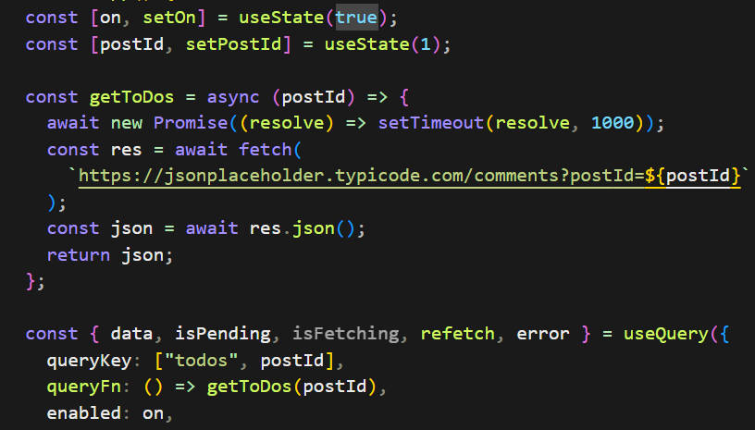
- Above, we created one hook with on. We added enabled prop and set to on (Boolean) to useQuery. Whenever this is true, useQuery is called, and whenever it is false, it is not going to run everytime react rerenders the component
- Lets say Boolean is set to false, and now the query will not run automatically, but if we reFecth, query will get executed. In a component, we may have multiple useQueries and certain useQuery is not required to run based on some state values (Boolean), That’s where we can use enable prop of useQuery hook
- Sometimes, our query options get complex
- 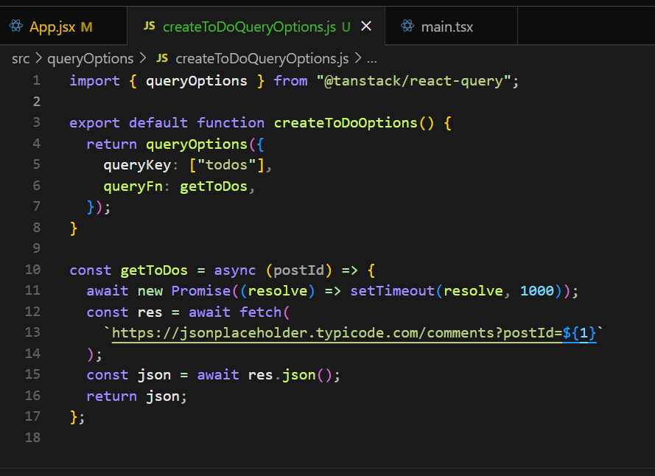
- Above, we created a separate folder(queryOptions) and file (createToDoQueryOptions) and then we called the function in the app component. In this way, we can reuse the same query for multiple components. Below,
- 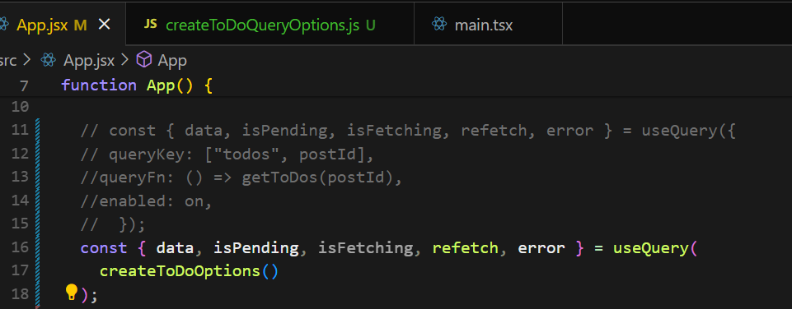
- We destructured data from useQuery hook. This data is of type ‘any’. If we write data.hello the page crashes. And it says can’t read properties of undefined, (reading hello). So we mentione type as below pic,
- 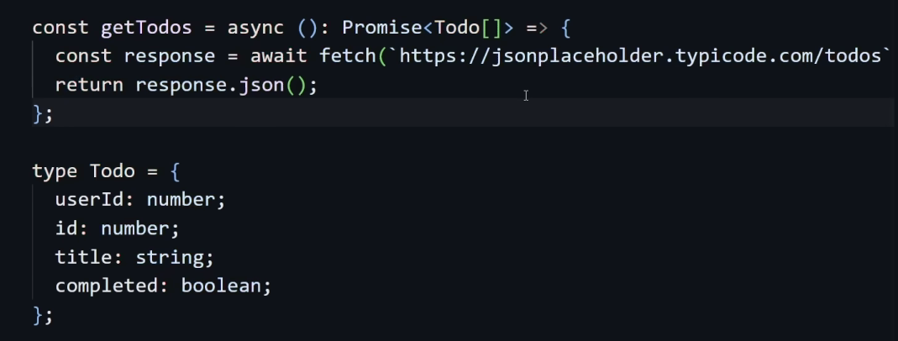
- Since async returns a promise we added Promise keyword. Now if we hover on data (in destructuring part) it will show, todo[] and undefined.
- If I give {data[0].id} it works but if I give {data[0].hello},it shows error as hello doesn’t exist
- If we r working with TS, data (in destructuring part) may show as undefined, coz anytime we try to access properties of a return obj or array, we may get this error and it is valid, as data could be undefined
- We can use ‘useSuspenseQuery’ and it guarantees that data will never be undefined
- 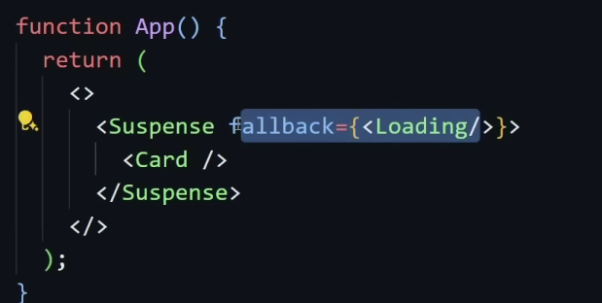
- Another use of ‘useSuspenseQuery’ is, lets say we have ‘useSuspenseQuery’ in Card component. If that query is not resolved, then the fallback Ui will be shown. This Suspense if from react and we already learnt this in Lazy loading
- One problem is we cant use enabled option in useSuspenseQuery (conditional querying)
- We can have many queries in a single component.
1. Running multiple queries at same time
2. Multiple queries need to run in a certain order. Coz the result of one query may be passed down to the request of an another query.
3. Multiple independent queries( useQueries)
- Above, see we passed an obj
- 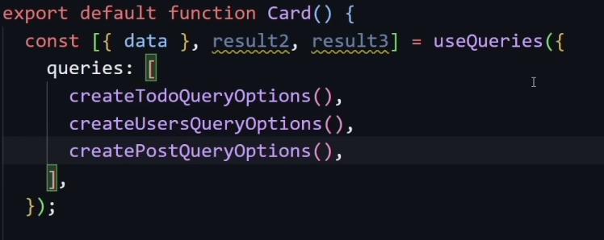
- Instead of useQueries, we can also use useSuspenseQueries. This does not work when the options of one query depend on the result of other query
- For example, in 1st query result, we r getting userID which we need pass to the 2nd query. This is where we can make use of enabled option of useQuery. Below,
- 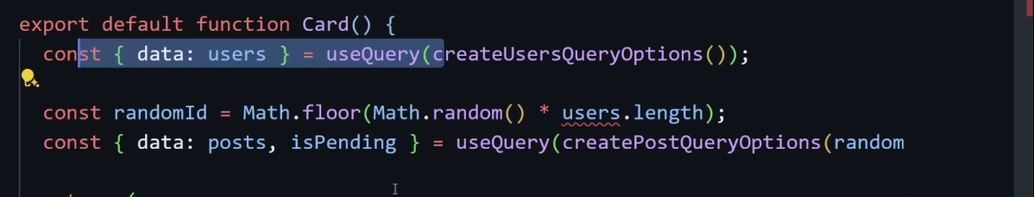
- Above, in 1st query data is renamed as users in destructuring part.
- 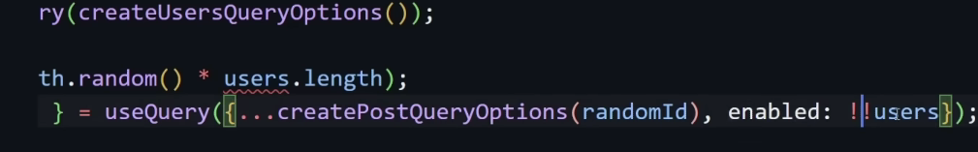
- Above, see !!users, if it is defined, 2nd query will run. And see how we destructured. !! converts the value into Boolean. So !!users means, if users exists, the 2nd query will run. Or another way is making the 1st query as useSuspenseQuer which means users will always be defined. Below,
- 